SAS Basics

The purpose of this handout is to give you a brief overview of how you can use SAS in your research. It is not intended to replace the many SAS user’s guides and manuals that are available, although it covers pertinent material from those guides. In fact, I recommend using the countless resources available online as a supplement to this guide.

I. Getting Started

A. “Programming”

While we often refer to the work we do in SAS as “programming”, in reality the programming has already been done in the background so that we can simply execute the “canned” routines that real programmers have prepared for us. We’ll be learning about some of the most commonly used SAS routines today.

- SAS Platforms

Until a few years ago, SAS could only be run on a Unix mainframe. SAS has also become available (and widely used) in a Windows version called PC SAS. This version is run on a windows-based PC. PC SAS is not available for Macintosh machines; if you have a Mac, you’ll need to either run Windows on your Mac, or use PC SAS on a campus computer-lab machine.

C. Using PC SAS

Penn has a site license for PC SAS. I strongly recommend that you use PC SAS. It has a lot of great features that make using SAS easier. For example, it automatically color codes your SAS code so that you can easily see the different steps in your program.

II. Basic SAS Statements

- Data Manipulation

When I say “data manipulation”, I don’t mean “altering” or “falsifying” the data. I’m talking about getting your data into the format you need to run your analysis. The next task is to merge it together so that you can do something meaningful with the data. The following SAS statements are some of the most commonly used statements in getting your data ready for analysis. Note that the examples of SAS code are all listed in lower case letters. SAS is not case sensitive, so it will interpret “varname”, “VARNAME” or “Varname” to mean the same thing. Also, note that all SAS statements must end with a semicolon (;). [The most common error new SAS users make is to forget a semicolon at the end of a SAS statement. SAS will keep on reading until it hits a semicolon and it will count everything in between as one statement.]

1. The Data Step

The data step is the MOST important and commonly used tool in SAS. It always begins with the word "data" and then the name of the new dataset you're creating. It is generally followed by the "set" statement, which assigns a previously used dataset to the newly created one. It is within the data step that you define new variables. The data step is concluded with a “run” statement, which tells SAS to execute the previous statements. The following example shows how new variables can be created within a data step.

data newname;
set oldname;
newvar1 = oldvar1 + oldvar2;
newvar2 = log(oldvar3);
newvar3 = sqrt(oldvar4);
newvar4 = oldvar3*oldvar5;
newvar5 = oldvar4/oldvar2;
run;

In this example, the name of the dataset is “newname”. This new dataset is being created from a previously referenced dataset called “oldname”. This data step creates five new variables from previously defined variables. “Newvar1” is defined as the sum of oldvar1 and oldvar2. “Newvar2” is the natural log of oldvar3. “Newvar3” is the square root of oldvar4. “Newvar4” is defined as oldvar3 multiplied by oldvar5. Finally, “newvar5” is defined as oldvar4 divided by oldvar2. Obviously, you’ll want to use variable names that make sense in the context of your own research.

2. Common Data Step Statements

Several statements are commonly used within the data step: “keep”, “drop”, “rename”, “where”, and “if”.

a. Keep Statement

Use the “keep” statement to tell SAS you only want certain variables written to the new dataset. SAS will throw out any variables not included in the keep statement. The syntax is:

keep var1 var2;

b. Drop Statement

Instead of listing all the variables you want to keep, you can use the “drop” statement to tell SAS to eliminate certain variables. SAS will keep any variables not included in the drop statement. The syntax is:

drop var3;

c. Rename Statement

You can rename variables within a data step by using the “rename” statement. The syntax is:

rename oldvar1=newvar1 oldvar2=newvar2;

The variables are renamed just before the new dataset is written, so if you need to reference a variable that is being renamed (e.g. you are using var1 in a calculation), reference the old name.

d. Where Statement

The “where” statement can screen observations as they are being read from the old dataset. This improves the efficiency of your programs, since SAS only reads and processes observations that meets a given criteria. There can be only one “where” statement in a given Data Step or Proc. The syntax is:

where var1>0;

e. If Statement

While the “if” statement can be used for logical operations (e.g. if var1>0 then positive=1)

if var2>0 then createnewvar=1

you can also use the “if” statement to screen observations as they are being written to the new dataset. Only observations that meet the criteria are written to the new dataset; all others are eliminated. The syntax is:

if var2>0;

If you are trying to read specific data from a large dataset, the “where” statement is more efficient than the “if” statement since it screens observations before they are processed rather than after. However, you can only use one “where” statement per data step and unlimited “if” statements. If statements can be used in Data Steps but not Procs.

f. Examples

Here is an example of all of the statements are used separately the data step.

data newdata;
set olddata;
where var1>0;
rename var1=newvar1 var2=newvar2;
keep newvar1 newvar2 newvar3;
if var2>0 then newvar3=1;
run;

3. Accessing Existing SAS Datasets & Saving New Permanent SAS Datasets

What if you want to start a new program by accessing data that you created and stored previously in a SAS dataset? How do you reference the data in an existing SAS dataset? This is a very useful tool in SAS. If you’ve already saved data in SAS format, you can call that dataset up at any time.

SAS datasets are stored in a “directory” (a folder). To reference a dataset, you need to reference its exact location. The most common way to do this is to provide a name for the directory where the dataset resides. You can then reference this name whenever you reference datasets in the directory.

Name a directory by using a “libname” statement, as follows:

libname mydata ' m:\'; (notice, no “run” statement is required.)

data sample;
set mydata.Compustat;
run;

The “mydata.” piece of the code is where I reference the directory where my SAS dataset is stored (this is officially called a “libref”). I now have a temporary dataset called “sample” that contains everything in the permanent Compustat dataset.

NOTE: By default, datasets are stored in a temporary directory called “work” that is deleted when SAS closes. If you don’t specific a libref when referencing a dataset, SAS assumes you are referencing this “work” directory

B. Debugging Errors

When your program is not behaving the way you think it should, 99.9% of time it is because you typed something incorrectly. (For the other 0.1% of the time, restart SAS and see if the problem continues.)

The SAS documentation has some great examples of common errors, as well as an explanation of how SAS handles the error. This will be extremely helpful to you as you debug your own code and become an independent SAS programmer. The site is here: http://support.sas.com/documentation/cdl/en/lrcon/62955/HTML/default/viewer.htm#a000993446.htm.

C. Other Helpful Tools

1. Removing Duplicate Observations

You can get rid of duplicate observations using the sort procedure. In the code below, the dataset is sorted by GVKEY and DATADATE. The “nodups” option tells SAS to eliminate duplicate observations.

proc sort data=mydata nodupkey;
by GVKEY DATADATE;
run;

Suppose my dataset looked like this:
GVKEY Datadate Net_Income
001004 31DEC1992 2052
001004 31DEC1993 3062
001004 31DEC1993 3092
001004 31DEC1994 4106

Technically, there are no duplicate observations, but I have two observations for 31DEC1993. Using the “nodupkey” option will not solve this problem. Instead, proc sort has a “nodupkey” option, where it treats the “by variables” (GVKEY and DATADATE) as the primary key. When it encounters duplicate entries for the same primary key (in this case 001004 31DEC1993) it keeps the first record and throws out any others.

2. Viewing Datasets (Or Parts of Datasets)

I use print statements frequently—to make sure everything looks right. If I'm using huge datasets, I don't need to look at every observation. (Imagine how long it would take SAS to print out 20,000 observations!) I'll often tell it to print the first 50, 100, or 200 observations (that is what the “obs=” option does). The print procedure always begins with "proc print" to tell SAS which procedure you're using. On the same line, you need to tell it which dataset you're using and if necessary how many observations to print. The var statement tells it which variables to print. (The default is to print all of your variables.) A title statement is good especially if you're printing multiple datasets, so you know what you're looking at when you examine the output.

proc print data=nasdaq (obs=100);
var PERMNO cusip ticker sales cogs;
title 'This is Data for the Nasdaq Sample';
run;

Running the following code at the beginning of your programs will make the printed output more readable.

options ls=250 ps=max nocenter; (Note: this is called an “options” statement.)

Instead of printing datasets, many users of PC SAS look at the datasets in a table format, similar to excel. The two screen shots below show you all of the libraries (including any libnames you have assigned) that are active in the current session. These libraries are just like folders in windows; double-clicking on them opens them up to reveal all of the datasets inside.

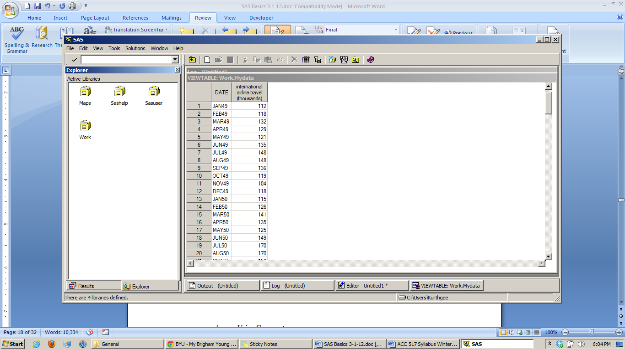

Opening the “Sashelp” library, we can see many different datasets, as well as some other SAS files.

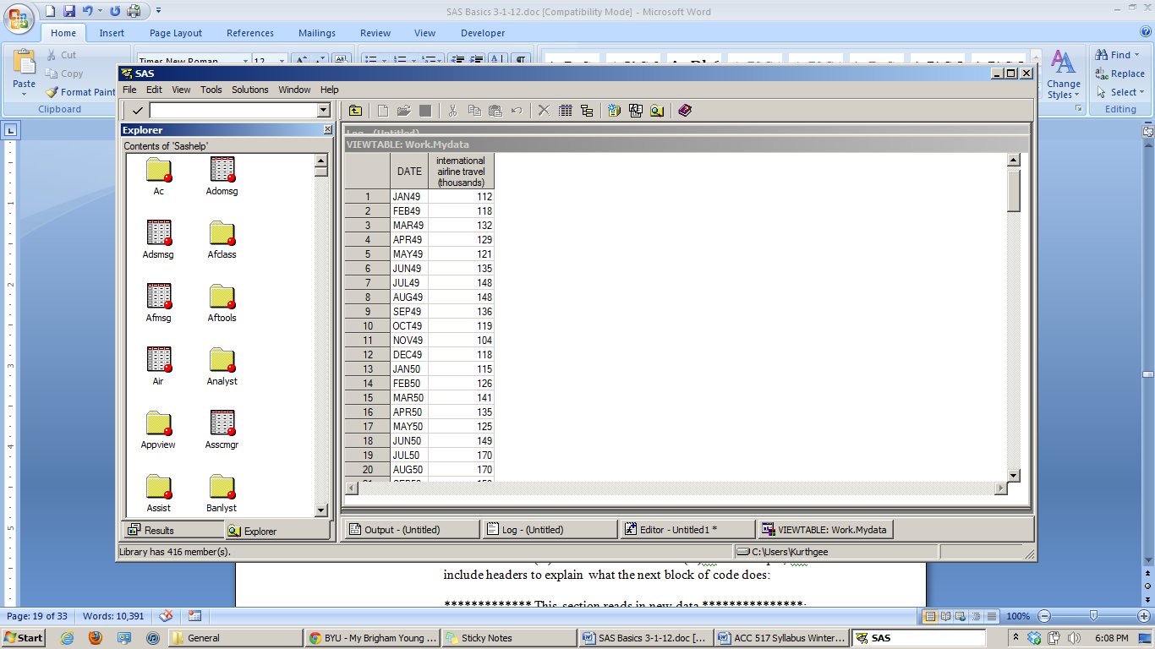

If we double click on the “Air” dataset, we can see the contents of the dataset, similar to an excel table (except that we can’t edit it.)

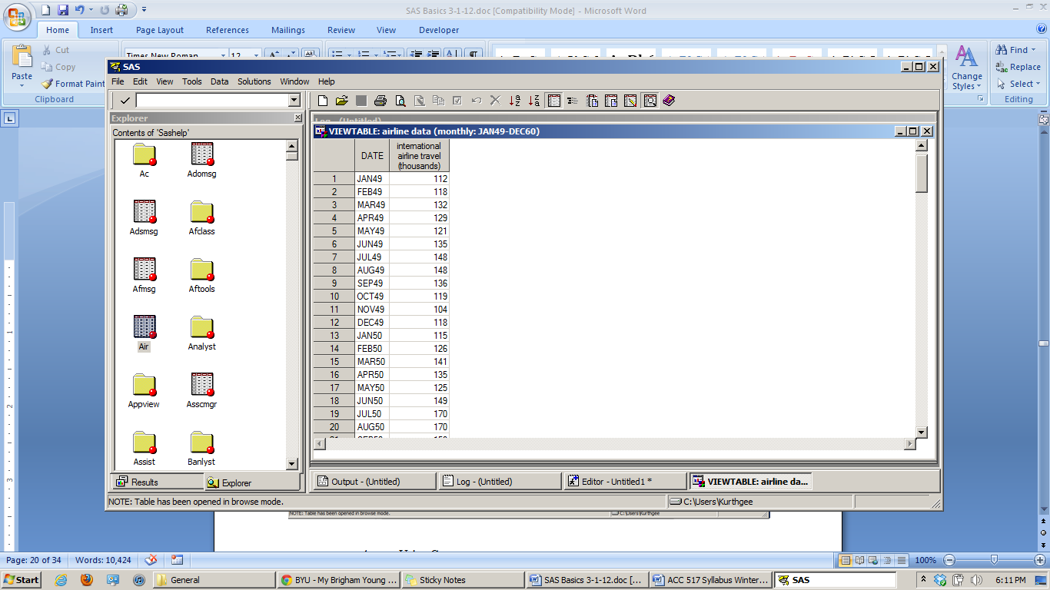

When you create a new library reference using a “libname” statement, you are essentially creating a new “folder” here. Each folder represents a library into which SAS can place datasets.

3. Using Comments

There are two common uses for comments. First, it is helpful to document what you’re doing so that you (or someone else) will be able to go through your program and quickly understand what each step is doing. Comment markers can also be used to cause SAS to “skip” sections of code that you don’t need at the moment, but that you think you might need later. There are two ways to comment out words or commands: (1) begin the statement with a star (*) and end with a semicolon or (2) begin with a slash star (/*) and end with star slash (*/). For example, I’ll often include headers to explain what the next block of code does:

************* This section reads in new data ***************;

The next set of comments causes SAS to completely skip these eight lines of code and proceed on with the next “uncommented” SAS command.

/*
proc sort data=price; by PERMNO; run;
proc sort data=earnings; by PERMNO; run;

data pricearn miss1 miss2;
merge price (in=a) earnings (in=b);
by PERMNO;
if (a eq 1) and (b eq 1) then output pricearn;
if (a eq 0) and (b eq 1) then output miss1;
if (a eq 1) and (b eq 0) then output miss2;
run;
*/

Note that the /*….*/ comments don’t require a semicolon while the regular “star” comments require you to place a semicolon at the end of the comment.

USING

PROC SQL

I. Introduction

We can use SQL statements inside the SAS environment. The syntax is exactly the same as normal SQL, so if you have SQL experience from somewhere else this may be very natural for you.

Rather than processing datasets linearly, one observation at a time (like a Data step does), SQL will query the entire dataset at once and return what you specify. While you can use SQL to create datasets as an alternative to data steps, the real power of SQL comes in its flexibility for merging data and calculating summary statistics (like mean, sum, count, or standard deviation).

We access SQL in SAS by submitting the statement below:

proc sql;

This statement acts like a switch and turns SQL “on”. SAS will interpret any new statements as SQL statements. We can run several queries one after another, without having to turn SQL “on” again. When we want to turn SQL “off” and return to normal SAS programming, we submit a quit statement (quit;)

Each SQL statement ends with a semicolon, just like SAS statements. SQL statements consist of different clauses, which specify what we want SQL to do. There are no “run” statements in SQL; instead, each statement is processed as soon as it is submitted.

Proc SQL can be used to create a new dataset from an old dataset just like a data step does. In the example below, Proc SQL will create a dataset (or table, as it is called in SQL) called “newdata” containing the variables “GVKEY”, “DATADATE”, “tot_asset” and “net_income”.

proc sql;
create table newdata as
select GVKEY, DATADATE, at as tot_asset, ni as net_income
from mydata.Compustat
where at>0;
quit;

- “mydata” is the libname, and “Compustat” is the name of the dataset.
- “as” after “create table newdata” tells SQL what variables we want in the table. Notice that variables are separated by commas. This is unique to SQL and is different from normal SAS programming (like we do in data steps).
- “as” after the variables “ni” and “at” tells SQL to rename the variable to something different
- “from” clause tells SQL where to read in data from
- “where” clause operates the same as in a data step. It restricts what is written to the new dataset to observations where total assets is positive (variable “at” on Compustat).

These clauses in the order shown (create, select, from, where) is what makes up almost all SQL statements.

We can also merge datasets together using Proc SQL. In the following example, we merge two datasets. The “inner join” specifies how we want to merge the two datasets (more below). The “on” clause specifies how the two datasets relate to each other. We could add more criteria with the “on” clause if desired.

proc sql;
create table newdata2 as
select a.PERMNO, a.DATADATE, a.ni as netincome,
b.consensus as eps_forecast
from mydata.Compustat a inner join mydata.ibes b
on a.PERMNO=b.PERMNO and a.DATADATE=b.DATADATE
where a.at>0;
quit;

This example merges Compustat and IBES files, on the basis of company (PERMNO) and date of fiscal year end (DATADATE). Here, the from statement uses a shortcut “a” to refer to. the table mydata.Compustat and a shortcut “b” to refer to the table mydata.ibes.

The select statement pulls PERMNO, DATADATE, ni from “a” and consensus from “b”. “ni” is renamed to “netincome” and “consensus” is renamed to “eps_forecast.”

“Inner Join” returns the intersection of the two datasets (only firms that are in both datasets). “Outer Join” would return the union of the two datasets (firms that are in funda, temp, or both). “Left Join” would return only firms that are in the left dataset and “Right Join” would return only firms that are in the right dataset.

SQL is often more efficient because it can do multiple things in the same step. For example, in the code below, Compustat and IBES files are merged on the basis of company (PERMNO) and date of fiscal year end (DATADATE). The resulting dataset is sorted (the “order by” clause) and duplicate records are removed (“select unique” is like the “nodupkey” feature in proc sort). Doing the same thing without SQL would require a data step and using proc sort, meaning SAS has to read and write the dataset twice instead of just once (which takes extra processing time).

proc sql;
create table newdata3 as
select unique a.PERMNO, a.DATADATE
from mydata.Compustat a inner join mydata.ibes b
on a.PERMNO=b.PERMNO and a.DATADATE=b.DATADATE
where a.at>0
order by PERMNO, DATADATE;
quit;

Suppose we want to find the total income of all firms in a particular industry, where the variable FFIC12 indicates industry. We can use the “sum” function to do this. The code below shows how this is done. The “group by” clause tells SQL how to calculate the sum. If you omit the “group by” clause, SQL thinks you want to treat the entire dataset as one “group”, so it will take the sum of all firms in all industries, instead of the sum for each industry.

proc sql;
create table industry as
select unique ffic12, sum(ni) as avg_net_income
from mydata.Compustat
group by ffic12;
quit;

For a list of all the summary functions in proc sql, visit here: http://www.sascommunity.org/wiki/Fun_with_PROC_SQL_Summary_Functions

II. Compounding returns using Proc SQL and joining CRSP and COMPUSTAT

You can use several tools to extract CRSP data for stock returns, but you still need a way to compound the returns over a specific interval (i.e. compute buy-and-hold-stock returns). Ideally, you’d add 1 to each monthly (or daily) return observation on CRSP, 1+r, and then tell SAS to compound the returns over a given interval [day t to day t + T]

$$\prod_{i=0}^{T}{(1+r_{t+i})}$$

Unfortunately, SQL doesn’t have a “product” function to multiply all the returns together. So we need to get creative and try and accomplish the same thing by other means. Recall that SQL does have a sum function (see above example). So how we can turn a sum function into a product function? You can accomplish the same thing by taking the natural log of (1+r), summing the log returns, then exponentiating and subtracting 1.

$$\prod_{i=0}^{T}{\left(1+r_{t+i}\right)=e^{\sum_{t=0}^{T}{ln⁡(1+r_{t+i})}}}$$

Suppose we want to calculate buy-and-hold return over the firm’s fiscal year (i.e., for each PERMNO-DATADATE pair). Here is what the SQL code looks like:

proc sql;
create table data2 as
select unique a.PERMNO, a.DATADATE,
exp(sum(log(1+b.ret)))-1 as fyret
from mydata.Compustat a inner join mydata.monthlycrsp b
on a.PERMNO=b.PERMNO and -11<=intck(“month”,a.DATADATE,b.date)<=0
group by PERMNO, DATADATE;
quit;

In this example, “PERMNO” is the company identifier, “DATADATE” is the fiscal year end, and “ret” is the name of the returns variable on the monthly CRSP file. In SAS, “log()” refers to the natural log, and “exp()” refers to taking e to some power.

Recall that the CRSP monthly file contains one observation per firm-month (e.g., IBM Dec 1999, 1% return). The above example compounds the firm returns over the firm’s fiscal year. To do so, we merge Compustat and CRSP on PERMNO, and then compound all returns over the 12 months ending on the fiscal year end date. This is where the INTCK function is useful.

1. INTCK Function.

This function measures the number of time intervals (“month”) between two dates. Time intervals can be day, weekday, month, quarter, or year. Here is the syntax:

intck('[interval]',date1,date2)

where [interval] is the interval you want (day, weekday, etc.) and date1 and date2 are date variables. The function starts at date1 and counts the number of intervals until date2. If date2 > date1, the result will be positive. If date2 < date1, the result will be negative.

Here are some examples of the function:

X=intck('weekday','31DEC2010'd,'3JAN2011'd)
the value of X is 1

Y=intck('month','31DEC2010'd,'4JUN2010'd)
the value of Y is -6

Having covered INTCK, let’s return to the above SQL command for merging CRSP and Compustat and constructing fiscal year return.

In the above example, SQL grabs all monthly return observations for each PERMNO based on whether the return is within t = –11,…, 0 months of the firm’s fiscal year end. For example for IBM with fiscal year end in Dec 1999, this would grab IBM’s returns from Jan 1999 [Dec 1999 – 11 months] to Dec 1999 [Dec 1999 – 0 months].

FIRM DATADATE DATE RET
IBM Dec 1999 Dec 1999 0.01
IBM Dec 1999 Nov 1999 0.02
IBM Dec 1999 Oct 1999 –0.01
… … … …
IBM Dec 1999 JAN 1999 0.03

Each firm-year is matched with corresponding monthly returns over the –11,0 interval, where date 0 is DATADATE.

Once the join is complete, we need the “group by” clause to tell SAS to aggregate the data by PERMNO, DATADATE in the same way as we aggregated by industry earlier. The “group by clause” tells SQL to perform any summary functions (functions like “sum” or “mean” that can handle more than one variable at a time) to all observations within each group. In this case, the group is each firm-fiscal year. SQL compounds returns for each firm and fiscal year, no matter how many observations there are. (Omitting the “group by” clause tells SQL to treat the entire dataset as one group.)

2. While the INTCK function will determine the number of intervals between two dates, the INTNX function returns a date that is a number of intervals away from a given date. The basic syntax is as follows (more advanced syntax can be found online in the SAS documentation):

intnx('[interval]', date1, [number of intervals])

Here is an example of the function being used:

x=intnx('week', '17OCT2003'd, 6);
the value of x is 23NOV2003.

BASIC
STATS
in SAS

Basic Statistical Analysis

1. Descriptive Statistics (Proc Univariate, Proc Means, and Proc Freq)

Proc Univariate is one of the most commonly used procedures. It returns information like mean, median, 25th percentile, 75th percentile, largest value, smallest value, sum of all values, along with a host of other statistical tests of the data. It's very useful. Note that you can add titles so that your output is more descriptive

proc univariate data=oldset;
var sales cogs advexp;
title 'Desc. Stats for Sales, COGS, and Advexp Variables';
run;

Proc Means is a simpler procedure that will only give you the basic statistics:

proc means data=oldest ;
var sales cogs advexp;
title 'Basic stats for Sales, COGS, and Advexp Variables';
run;

I prefer Proc Means when I want a brief printout to give me a general idea about the distribution of a set of variables. Proc Univariate is better when you are interested in details.

Proc Freq (pronounced “freak” as in “frequency”) is used to count the occurrences of particular values of a variable. It outputs a table listing the variable value, frequency, percent, cumulative frequency, and cumulative percent. The following outputs the number of observations on the dataset for each company name (CONM).

proc freq data=alldata;
tables conm;
by sample;
title 'Table 1, Panel A: Number of Observations per Firm';
run;

The following outputs the number of observations on the dataset for each fiscal year (FYEAR).

proc freq data=alldata;
tables fyear;
title 'Table 1, Panel B: Number of Observations per Year';
run;

2. Basic Correlations (Proc Corr)

Proc Corr will return basic correlations. You can specify both Pearson (parametric) and Spearman (non-parametric) correlations as illustrated in the following example:

proc corr data=fulldata pearson spearman;
var sales totasset returns;
run;

The “var” statement specifies which variables to include in the correlation tables. The default is to include all variables in the dataset.

3. Basic Regressions (Proc Reg)

Proc Reg is one of the most important SAS procedures. It allows you to run ordinary least squares regressions. Here is an example of a basic regression:

proc reg data=oldset;
model price = bookval income mktbook;
title 'This Regression Contains Data from the Large Firm Sample';
quit;

You always begin by specifying what dataset is to be used in performing the regression. The model statement defines the dependent and independent variables to be used in the regression.

4. Additional Programming Hints

I want you to learn to use SAS on your own and to develop independence. In the real world, coders do not always know the syntax for every step of their program at the time they start coding. Sometimes you can learn new “tricks” by searching on Google or the UCLA website, https://stats.idre.ucla.edu/sas/. Other times, you will learn by asking a friend or colleague. As I noted in the syllabus, “Learning is about knowing what you know, knowing what you don’t know, and knowing what questions to ask. It is your responsibility to identify gaps in your knowledge and take actions to remedy those gaps. In this regard, the class will entail significant hands-on learning outside of class.”

